Talosec – Daily SOC Report
Date: 31 December 2025
Prepared By: Ali Rayyan – SOC Analyst Intern
Case Tracking Code: CORD-20251231-AliRayyan-001
Environment: Wazuh SIEM + T-Pot Honeypot
Reporting Period: Last 24 Hours

1. Executive Summary
During the last 24 hours, the SOC observed continuous hostile internet activity targeting monitored infrastructure. The activity primarily consisted of automated reconnaissance, SSH brute-force attempts, and honeypot interactions.
Advanced investigation was conducted by correlating Wazuh alerts, host telemetry, and T-Pot honeypot data (Kibana, Honeytrap, SpiderFoot). The findings confirm that all observed malicious behavior was successfully detected and contained, with no evidence of system compromise.
Security controls, including Active Response firewall blocking, custom honeypot rules, and alert tuning, operated as expected.

2. Assets in Scope
Hostname | IP Address | Role
server01 | 10.0.0.45 | Honeypot host (T-Pot)
server02 | 10.0.0.97 | SSH-exposed system
Wazuh Manager | ip-10-0-0-27 | SIEM / SOC platform

3. Summary of Alerts (Wazuh – Last 24 Hours)
Alert Category | Observation
SSH Failed Login Attempts | Multiple attempts using non-existent users
Honeypot Interaction Alerts | High frequency (expected behavior)
File Integrity Monitoring | Legitimate admin/system activity
Listening Port Changes | Docker & honeypot service behavior
Active Response Events | Firewall blocks/unblocks triggered

4. Detailed Investigation Findings
4.1 SSH Brute-Force Activity
- Multiple external IPs attempted SSH access using invalid usernames
- Activity consistent with automated credential-guessing tools
- Wazuh rule 5710 triggered repeatedly
- Firewall-drop active response successfully blocked offending IPs
- No successful authentication detected
Assessment:
Malicious but contained
MITRE ATT&CK:
- T1110 – Brute Force
- T1078 – Valid Accounts (attempted)

4.2 Honeypot (T-Pot / Honeytrap) Investigation – Primary Focus
A deep investigation was conducted using T-Pot, including:
- Attack Map: Identified global attacker sources
- SpiderFoot: Enriched attacker IPs (ASN, hosting providers, reputation)
- Kibana (logstash-*): Correlated events by IP, port, country, and honeypot type
- Honeytrap logs: Reviewed attacker interaction and payload attempts
Observed Behavior
- High-volume TCP connections to random high ports
- Short-lived sessions with minimal data exchange
- Protocol banner strings observed:
  - SSH (SSH-2.0-OpenSSH)
  - SMTP (EHLO)
  - VNC (RFB)
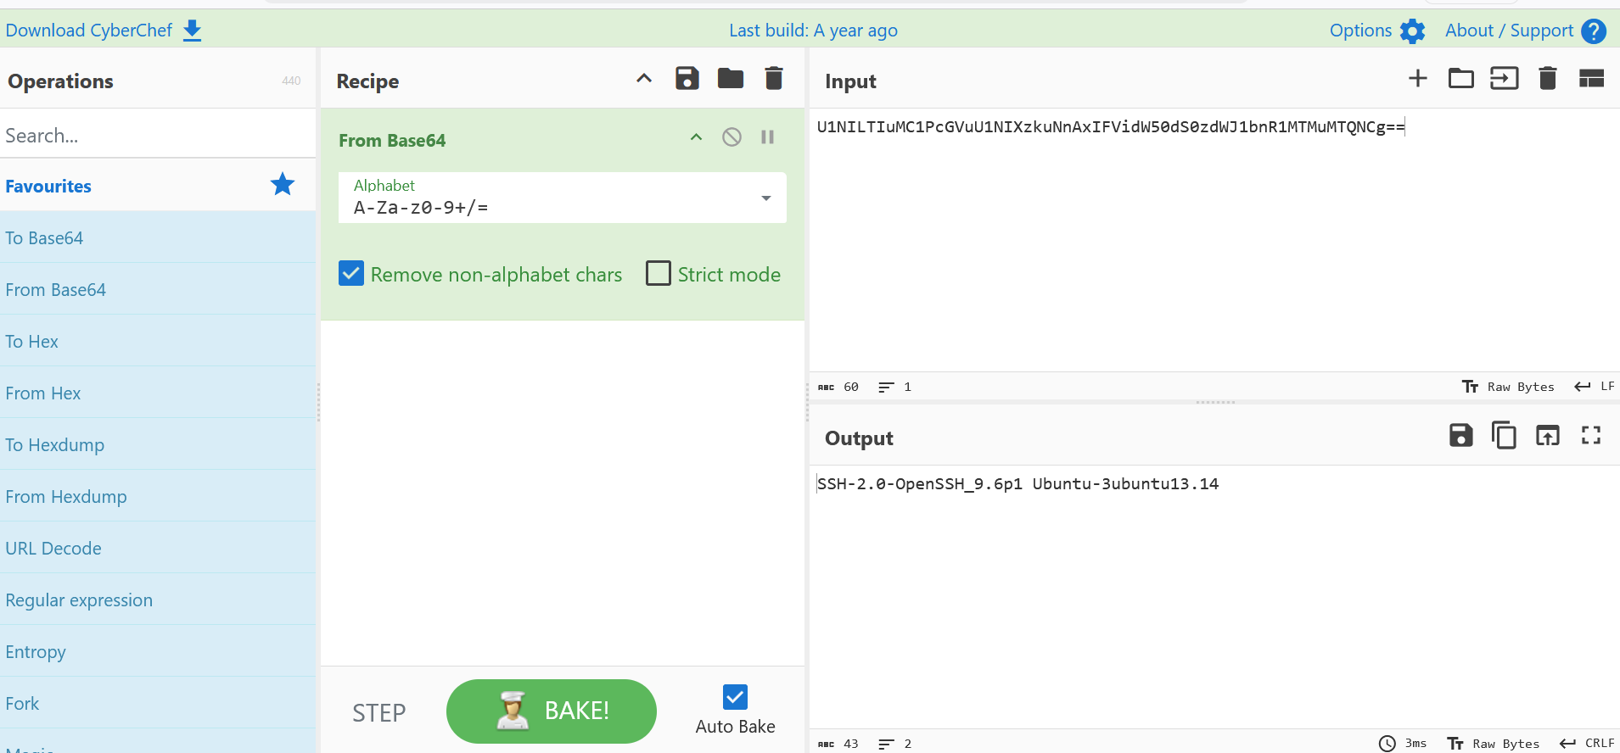
Payload Analysis
- Extracted printable payload fields
- Decoded payloads confirmed to be protocol identification strings
- No command execution, malware download, or exploit payloads observed
Assessment:
Expected honeypot reconnaissance activity
MITRE ATT&CK:
- T1046 – Network Service Scanning
- T1595 – Active Scanning

4.3 File Integrity Monitoring (FIM)
- Integrity checksum changes detected on:
  - /boot/efi/EFI/...
  - User .bash_history
  - System account files
- Changes correlated with:
  - Legitimate administrative actions
  - System updates
  - Honeypot log generation
Assessment:
Benign – validated and documented

4.4 Listening Port Status Changes
- Alerts triggered due to:
  - Docker container lifecycle events
  - Honeypot service restarts
- Netstat output confirmed only legitimate services
Assessment:
Operational noise
Action: Logged for tuning consideration

5. SOC Actions Performed Today
- Conducted end-to-end honeypot investigation
- Correlated attacker IPs across:
  - Attack Map
  - Kibana
  - Honeytrap logs
  - SpiderFoot
- Verified payload content using decoding techniques
- Validated Active Response firewall effectiveness
- Reviewed and documented integrity alerts
- Reduced false positives through analyst judgment

6. Risk Assessment
Risk Category | Status
External Reconnaissance | Observed
Exploitation | Not observed
Credential Compromise | Not observed
Persistence | Not observed
Lateral Movement | Not observed

7. Recommendations
- Continue monitoring honeypot interactions for escalation attempts
- Focus future analysis on:
  - Repeat attackers
  - Multi-service probing behavior
- Expand payload decoding workflows once exploit attempts are observed
- Maintain Active Response enforcement for SSH abuse
- Document honeypot findings as threat-research intelligence

